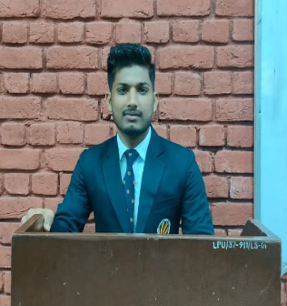

SUMMARY

Aspiring engineer driven by passion who loves solving problems in software engineering domain and constantly looking for opportunity that challenge and push his limits.

TECHNICAL SKILLS

Programming languages: Java , C++

Web Technologies:

Reactjs, HTML5, CSS, Bootstrap,

Expressjs, Nextjs,

Nodejs, Javascript, Tailwind css

Data Management:

MySQL, MongoDB, MS Access

Tools:Git, Github, Firebase

Expertise: Data structure and Algorithm

OS , CLOUD , OOPS , NETWORKING

CERTIFICATIONS

Frontend Development | The Infinity Board | Jun '23 Reactjs Development| Cipher

INTERNSHIP

# 

Student Counselor Jun '22 - Jul '22

Lovely Professional University | Phagwara, IN

Guided more than 1,000+ student in tech related domain

Gained hands-on experience in understanding the admission process, also understand complete tech stack and requirement of technologies.

Placement Coordinator

Conducted more than 15+drive got to know more about the companies and their hiring process.

PROJECTS

Code with Buddy

MERN(MongoDB, Nodejs, Express, Tail Wind, CSS, Socket.io) Jul’22

Code Editor, Compiler, White Board

Code with companion online through video chatting (inviting through link)

Session can be recorder

Movie Search Website Jun'22

Domain: Application | Reactjs, MovieDb Api

Constructed an application to get the information of movie rating Data on website rendered thorugh moviesDb api automatically Utilized all redux tool,react carsouel , build skeleton while loading

BharatSe(Protected Filesharing Website) Mar'22

Domain: JavaScript Nodejs Express MongoDb | Programming

Unique link get generated.

Upgraded code to make the error-free

Password protected using module like bcrypt, ejs, JavaScript, and JSP

Links

# 

POWER SKILLS

Team Player

Adaptive

Quick Learner

Pressure Handling

Leetcode- https://leetcode.com/_rwart/ Codechef- https:[//www.codechef.com/users/rwart](http://www.codechef.com/users/rwart) Github-https://github.com/rwart8878

EDUCATION

# 

B.Tech. in Computer Science Apr '20 – Present Lovely Professional University | Phagwara, IN

Higher Secondary Jun '14 - Mar '19

Dav Rb Kedia High School |

Birgunj,Nepal 90.80% 10th Dav Rb Kedia School Birgunj,Nepal CGPA 10